DEFIANCE COLLEGE

RN TO BSN ONLINE COMPLETION PROGRAM

Preceptor Guide

NRS 476 Community Nursing Clinical
This course is the clinical component of Community Health Nursing. It will include clock hours of clinical that are in alignment with CCNE accreditation standards and take place within the students’ local health department. The nursing program will secure a clinical site for the student within their state of nursing practice. It will include a formal paper including data from the community’s assessment and a clinical project agreed upon by the agency and the student to serve the needs of an underserved population. A formal paper and a presentation are required. Agency requirements may incur additional fees.
NRS 498 Nursing Leadership Capstone
This course is a final measure of the nurses knowledge, Skills, and Attitudes of the professional nurse in a health care setting. Under the direction and mentoring of a Chief Nursing Officer (CNO) the following leadership and management skills will be observed: strategic planning, organizational structure and culture, communication, conflict resolution, budget planning and evaluation, human resource issues, power and politics, teambuilding and working with collaborative multidisciplinary teams. The nursing program will secure a clinical site for the student within their state of nursing practice and the student will be responsible for working with the CNO to include clock hours of clinical that are in alignment with the CCNE accreditation standards and working with the CNO for a PICOT project (Population/Patient, Intervention/Indicator, Comparison/Control, Outcome, and Time). This is to be agreed upon by the CNO and nursing student. A final paper and presentation of the PICOT project is required. Prerequisite: This is to be the capstone and should therefore be scheduled as the last course in the student’s final term. Agency requirements may incur additional fees.

Dr. Heidi DeSota, DNP, RN Cathy Behringer
Director of Nursing Administrative Assistant
Phone: (419) 783-2372 Taskstream Coordinator
hdesota@defiance.edu Phone: (419) 783-2573
or Nursing@defiance.edu cbehringer@defiance.edu
or Nursing@defiance.edu

Revised 5/15, 12/15, 1/16, 5/17, 1/18, 6/18, 9/18, 4/19, 5/2020, 10/2020, 6/2021, 10/2021, 8/2022
Table of Contents

RN to BSN Completion Program Overview 2-6
Program Philosophy 2
Program Description 3
Program Learning Outcomes 4
Baccalaureate Essentials 5-6
Basis of Clinical 7-8
Student Requirements for Clinical Course 9-11 Active Ohio RN Licensure 9
Health Requirements 9
Criminal Background Check 10
Mandatory Drug Screening 10
Professional Liability and Health Insurance 11
Cardio-Pulmonary Resuscitation (CPR) Certification 11
HIPAA Training Policy 11
Identification Badges and Patches 11
Course Specific Requirements 11
Process for Beginning Clinical Experience 12
Responsibilities for Students’ Clinical Schedule and Reports 13
Preceptor Forms and Instructions 14-23
Preceptor Information 15-16
Preceptor Contract 17-18
Preceptor Evaluation of Student Performance 19-20
Preceptor’s Interaction Regarding Faculty 21-22
Assessment Notes 23
Clinical Evaluation of Agency and Preceptor Form 24
Student Forms and Instructions 25-28
Documentation of On-Site Clinical Experience 26
Documentation of Project Hours Clinical Experience 27
Student’s Assessment of Experience with Preceptor 28
Addendum: Adult Learning Styles 29-34
Directory 35

RN to BSN Online Completion Program Overview

RN to BSN Online Program Philosophy

The RN to BSN completion program philosophy is guided by the Essentials of Baccalaureate Education for Professional Nursing Practice (2008). This philosophy reflects the faculty’s beliefs about the nature of nursing and nursing education, people and their environment, and health and illness. As autonomous professionals who know and value the necessity of interdisciplinary collaboration, baccalaureate generalist nurses are part of an interprofessional health team which provides comprehensive care to individuals, families, and communities.

Nursing includes assessment, diagnosis, and treatment of human responses to actual or potential health problems and the planning, implementation, and evaluation of nursing care. The practice of nursing is based on nursing science, which includes knowledge of principles that govern life processes, the patterning of human behavior, the nature of human beings, and human interaction. The health care needs of individuals, families, and communities are defined within the context of personal, cultural and ethnic values, and social systems that influence function and resources. Therefore, a sound liberal and professional education is required to understand the complexity of responses. The need for evidence-based outcomes to improve human health and patient care is the stimulus for research into nursing practice.

Professional nurses are committed to the overall goal of health promotion, assisting persons of all ages to attain, maintain, and regain their health, and enhancing the quality and safety of their lives. Dedicated to the care and nurturing of the sick and well in order to help them achieve maximum human functioning, nurses help people achieve and maintain a healthy state, meet their basic needs, adapt to changes in their health status, recover from illness, and die with dignity. Humanistic, ethical and scientific principles drawn from nursing science and other fields form the theoretical base of nursing care for individuals, families, and groups. Individuals, families, and communities retain responsibility for their own health and the right to make decisions regarding health care.

People are complex organisms and human behavior and biological functioning are a result of the interaction between individuals and their environment. Humans are endowed with hereditary qualities that may be influenced in temporary or permanent ways by the interaction with others and the environment. Each person possesses strengths and limitations as a result of the interaction of hereditary and environmental factors and these, in turn, create the biological and behavioral potential.

Scientific principles related to the interplay of the mind, body, and spirit form the basis of our understanding of health and illness. Health is a dynamic state in which a person’s developmental and behavioral potential is realized to the fullest extent possible. Illness is the alteration of normal biophysical and social-psychological mechanisms.

RN to BSN Completion Program Description

The major in Nursing at Defiance College leading to the BSN degree is a completion program designed for Associate Degree prepared nurses or Diploma prepared nurses who graduated from an accredited nursing program and have a current unrestricted RN licensure. Students must also have a GPA of 2.5 or higher to be admitted into the program. Students must complete the required Defiance College general education curriculum courses as well as the advanced nursing courses. The program will be offered in an online format to accommodate various working schedules. All nursing major courses are offered in an online format. Baccalaureate prepared nurses have a broad base of learning that combines the technical aspects of nursing with the leadership skills necessary to lead in today’s dynamic health care environment. Students will gain additional knowledge in the liberal arts and take nursing courses to prepare them for leadership positions.

Recognizing that the student is already an RN, the focus will be on professional development that includes the following knowledge and skills:

- Examining current issues and trends in health care, such as nursing informatics, and patient care technology
- Developing writing, peer review, presentation, and communication skills through a liberal education
- Learning to apply research within the context of evidence-based practice
- Expanding critical thinking skills and organizational skills as they relate to improving patient care outcomes through prevention and health care education
- Using leadership skills in planning, implementing, and evaluating nursing care and participating in nursing policy development
- Work in interdisciplinary teams to benefit individual patients and underserved populations.
- Develop basic understanding of agency financial and budgetary concerns.

Defiance College
RN to BSN Completion Program
Program Learning Outcomes

- Develop caring professional values within a legal and ethical framework of nursing practice.
- Synthesize knowledge from the liberal arts and nursing curriculum to become a provider of quality care in a safe environment.
- Practice as a nurse generalist within the framework of diversity.
- Integrate technology into professional nursing practice.
Incorporate effective communication principles to produce positive professional relationships.

- Incorporate effective communication principles to produce positive professional relationships.

- Establish a foundation for lifelong learning and nursing scholarship.
- Integrate community nursing concepts as a coordinator of care utilizing the nursing process and critical thinking.
- Apply nursing research and scientific inquiry to fulfill the leadership role of a nursing professional.

American Association of Colleges of Nursing (AACN) Essentials of Baccalaureate Education for Professional Nursing Practice (2008)

The American Association of Colleges of Nursing (AACN) Essentials of Baccalaureate Education for Professional Nursing Practice (1998, 2008) was used to guide course development for the RN to BSN Completion Program. These essentials emphasize concepts such as patient centered care, interdisciplinary collaboration, evidence based practice, quality improvement, patient safety, informatics, clinical reasoning, critical thinking, cultural sensitivity, professionalism, and practice across the lifespan in a health care system that is constantly changing with clients who are complex in their needs. The AACN essentials are as follows:

Essential I: Liberal Education for Baccalaureate Generalist Nursing Practice
- A solid base in liberal education provides the cornerstone for the practice and
education of nurses.

Essential II: Basic Organizational and Systems Leadership for Quality Care and
Patient Safety
- Knowledge and skills in leadership, quality improvement, and patient safety are
necessary to provide high quality health care.

Essential III: Scholarship for Evidence Based Practice
- Professional nursing practice is grounded in the translation of current evidence
into one’s practice.

Essential IV: Information Management and Application of Patient Care Technology
- Knowledge and skills in information management and patient care technology
are critical in the delivery of quality patient care.

Essential V: Health Care Policy, Finance, and Regulatory Environments
- Healthcare policies, including financial and regulatory, directly and indirectly
influence the nature and functioning of the healthcare system and thereby are
important considerations in professional nursing practice.

Essential VI: Interprofessional Communication and Collaboration for Improving
Patient Health Outcomes
- Communication and collaboration among healthcare professionals are critical to
delivering high quality and safe patient care.

Essential VII: Clinical Prevention and Population Health
- Health promotion and disease prevention at the individual and population level
are necessary to improve population health and are important components of
baccalaureate generalist nursing practice.

Essential VIII: Professionalism and Professional Values
- Professionalism and the inherent values of altruism, autonomy, human dignity,
integrity, and social justice are fundamental to the discipline of nursing.

Essential IX: Baccalaureate Generalist Nursing Practice
- The baccalaureate graduate nurse is prepared to practice with patients,
including individuals, families, groups, communities, and populations across
the lifespan and across the continuum of healthcare environments.

- The baccalaureate graduate understands and respects the variations of care, the increased complexity and the increased use of healthcare resources inherent in caring for patients.

Reference:
American Association of Colleges of Nursing (2008). The Essentials of Baccalaureate Education for Professional Nursing Practice. Retrieved 1/23/18 from http://www.aacnnursing.org/Portals/42/Publications/BaccEssentials08.pdf

Basis of Clinical

Overview
Students in the RN to BSN Completion Program are required to take the following two (2) clinical courses as part of their nursing curriculum:

- Nursing 476 Community Health Clinical

This course is the clinical component of Community Health Nursing. It will include clock hours of clinical that are in alignment with CCNE accreditation standards and take place within the students’ local health department. The nursing program will secure a clinical site for the student within their state of nursing practice. It will include a formal paper including data from the community’s assessment and a clinical project agreed upon by the agency and the student to serve the needs of an underserved population. A formal paper and a presentation are required. Agency requirements may incur additional fees.

- Nursing 498 Nursing Leadership Capstone
This course is a final measure of the nurses knowledge, Skills, and Attitudes of the professional nurse in a health care setting. Under the direction and mentoring of a Chief Nursing Officer (CNO) the following leadership and management skills will be observed: strategic planning, organizational structure and culture, communication, conflict resolution, budget planning and evaluation, human resource issues, power and politics, teambuilding and working with collaborative multidisciplinary teams. The nursing program will secure a clinical site for the student within their state of nursing practice and the student will be responsible for working with the CNO to include clock hours of clinical that are in alignment with the CCNE accreditation standards and working with the CNO for a PICOT project (Population/Patient, Intervention/Indicator, Comparison/Control, Outcome, and Time). This is to be agreed upon by the CNO and nursing student. A final paper and presentation of the PICOT project is required. Prerequisite: This is to be the capstone and should therefore be scheduled as the last course in the student’s final term. Agency requirements may incur additional fees.
Students are required to spend 80 hours (40 hours on site / 40 hours on project/paper) during the semester focused on clinical learning integral to the respective courses. Students spend their clinical hours with a CNO at a local hospital or higher learning institution with a dean or director of nursing. Designated preceptors provide supervision. Clinical hours are fulfilled through an onsite clinical experience and through an offsite clinical related project that is presented to the preceptor agency in a written, power point, or a pamphlet presentation.

Preceptors are clinical expert nurses who have preferably earned, at a minimum, the BSN degree and have two years of experience. As healthcare and community-based resources, preceptors contribute significantly to the BSN students’ learning and professional socialization. Preceptors and faculty work collaboratively to maximize potential for student learning. It is the responsibility of the DON/Course Faculty to secure clinical sites for students; however, students have the ability to contribute in choosing their own preceptor in the clinical courses. The DON at DC will send a list of possible sites to students and they will have 1 week to respond with their top 3 choices. The student can also identify another site/preceptor not on the list and the DON will contact the agency to initiate an Education Affiliation Agreement and attempt to secure the site/preceptor.
In consultation with their preceptors and faculty, students will determine the clinical activities consistent with the course objectives developed by the faculty. Students will work with their preceptor to define two (2) specific clinical objectives they would like to achieve for the course. Students will be required to track their on-site clinical hours using the electronic forms provided within Taskstream (see pages 24-25). Students will have a minimum of one email or phone call from their clinical faculty during the semester. By week 3 of the clinical courses (NRS 476 and NRS 498), the nursing faculty teaching those courses will notify the preceptor to visit in person or virtually (if the site location is more than 30 miles from DC) to check on student progress and address any issues.
Students can distribute their clinical hours across the eight-week semester to meet the course objectives, or complete hours in a more concentrated fashion. The student will work with the preceptor based on the student and preceptor needs. No student may be assigned to a unit or direct reporting department where they are employed. Clinical time for which students receive financial or other compensation will not be counted as clinical hours.

Student Requirements for Clinical Courses

All requirements must be completed before the start of any clinical course.

The student is advised to begin the process early so there is no delay in completing the clinical hour requirements for the courses. It is the student’s responsibility to keep all required CPR and immunizations up-to-date. Failure to comply will result in missed clinical opportunities.

- ACTIVE UNENCUMBERED RN LICENSURE

- HEALTH REQUIREMENTS
1. Verification of DPT immunization within the past ten years;
2. Verification of immune status or vaccine administration for the following
infectious diseases:
a. Hepatitis B
b. Mumps
c. Rubella
d. Rubeola
e. Varicella
3. Mantoux TB Test. If there is a history of a positive PPD, then a chest x-ray less
than ten years old is required and/or whatever the agency requires.
4. Current Influenza Vaccination (Seasonal)
5. COVID-19, if required by Precepting Agency.

Some health requirements require a YEARLY update and it is the student’s responsibility to assure that the tests are completed and the report is submitted to the RN to BSN Online Completion Program via Taskstream, as indicated below.

Students who are pregnant or think they are pregnant should report their condition to the course faculty. Some health requirements may be waived for pregnant students or for individual students whose situations may warrant such action.

All health records should be emailed to Cathy Behringer (cbehringer@defiance.edu) Nursing Administrative Assistant.

- CRIMINAL BACKGROUND CHECK

Students are required by state law to complete a criminal background check. Students must be fingerprinted before they begin their initial clinical experience for the purpose of identifying those who may have a criminal record. Students with a criminal record may be denied the ability to participate in clinical study based on agency and Defiance College policies. Results should be mailed directly to the address below.

Background checks from current or previous employers will not be accepted due to the contractual agreement(s) the College has with the clinical agencies. The Criminal Background Check must include BCI and FBI checks. These results need to be sent to:

Cathy Behringer, Administrative Assistant
Attn: Defiance College Nursing
701 N. Clinton Street
Defiance, Ohio 43512

- MANDATORY DRUG SCREENING

All students enrolled in a clinical course are required to provide a sample for a urine drug screen. This is a requirement among agencies that accept our students for clinical experience. The RN to BSN completion program requires that you get your urine screen done at a local health care facility. Please call ahead of time to assure the availability of personnel and to schedule a time for a 10-panel drug screening urine test. No previous drug screening results will be accepted. Students who have not completed a drug screen will NOT be permitted in any clinical setting. The program director and clinical faculty member will be notified of students who are non-compliant. Should a student’s drug screen be positive, the student must have another drug screen completed within 24 hours at an agreed upon lab, and the results should be sent to the RN to BSN Online Completion Program (see address above). If positive results are obtained, the student will not be able to attend clinical. Students will be responsible for the cost of drug screening, both initial and follow-up, if necessary.

Drug screenings from current or previous employers will not be accepted due to the contractual agreements the College has with the clinical agencies.

- PROFESSIONAL LIABILITY AND HEALTH INSURANCE

All RN to BSN completion program students are required to have professional liability insurance in the minimum amount of $1,000,000/occurrence and $6,000,000/aggregate during NRS 476 and NRS 498 courses. Defiance College requires that all students carry health insurance through a family, employment, or student policy. See Defiance College Student Handbook & Academic Planner for specific information.

- CARDIO-PULMONARY RESUSCITATION (CPR) CERTIFICATION

The only certification that is acceptable:
- American Heart Association, BLS for the Health Care Provider

Students need to be certified in CPR before they can participate in clinical course work. It is up to each student to make sure that evidence of CPR certification is provided to the RN to BSN Online Completion Program through the uploading of their card, both front and back, to their personal Taskstream e-Portfolio.

- HIPAA TRAINING POLICY

Every student in the RN to BSN Online Completion Program is required to read and electronically “sign” the Health Insurance Portability and Accountability Act (HIPAA) Agreement Form through Taskstream. Students may need further training regarding HIPAA prior to beginning clinical experience at individual facilities.

- IDENTIFICATION BADGES

- All students in the RN to BSN Online Completion Program will wear professional clothing (scrubs & lab coat or slacks/skirt & lab coat). Each student will wear their Defiance College identification badge including RN designation and should be prominently displayed on their outer clothing.
- Identification badges for lab coats will be provided at orientation or through mail and are required for clinical.

Course Specific Requirements: Students are responsible for meeting all requirements mandated in respective course syllabi and the Preceptor Guide.

Process for Beginning of Clinical Experience
Student
- Attends virtual orientation prior to start of clinical semester
- Completes pre-clinical requirements
- Completes or is enrolled in NRS 400
- Reviews choices for a local health department for NRS 476 or a hospital CNO or higher education dean or director for NRS 498 and communicates top three choices to the DON at DC; Can also request another site of choice be sought out by the DON at DC to sign Education Affiliation Agreement

Nursing Faculty/DC DON
- Reviews student choices and secures clinical site for student; Reaches out to new agencies per student request for Education Affiliation Agreement if needed
- Provides preceptor with Preceptor Letter, Preceptor Guide, applicable syllabus, Preceptor Information Sheet, Preceptor Contract, and Preceptor Interaction Regarding Faculty evaluation via email by the end of week 8 of NRS 475 and NRS 480
- Notifies student of documentation completion and start of clinical
- Ensures preceptor documentation and agency contract is completed prior to week 1 of NRS 476 and NRS 498

Preceptor
- Completes and submits Preceptor Information and Preceptor Contract via email to DON (hdesota@defiance.edu) prior to week 1 of the clinical course. The Institutional Placement Agreement Form is available upon request for preceptors whose supervisors require permission prior to serving as a preceptor in their facility. Please send requests to cbehringer@defiance.edu.
- Negotiates schedule with student for clinical hours (40 hours on-site)

Responsibilities for Students’ Schedule & Reports
Nursing Faculty

- Works with student during the semester to develop two clinical objectives and clarification on project expectations.
- Will arrange a virtual of phone meeting with preceptor to check on student progress and address any issues week 3 of the clinical experience. Will also visit as needed in addition if any issues arise.
- Ensures students have developed two learning objectives by the second week of the semester as part of their evaluation.
- Collaborates with preceptor on reviewing the final evaluation of the student’s clinical performance. The course faculty will be responsible for completing the form and deciding on the student’s final points given for clinical.

Preceptor

- Reviews student’s documentation of on-site and project hours completed and agrees or disagrees via email to the course faculty.
- Collaborates with course faculty on reviewing the final evaluation of the student’s clinical performance. The course faculty will be responsible for completing the form and deciding on the student’s final points given for clinical.
Administrative Assistant

- Ensures that all documentation listed in the Preceptor Guide has been collected and submitted by the preceptor and student by the seventh week of clinical or capstone

Student

- Develops working relationship with agency and preceptor
- Coordinates scheduling or clinical hours with preceptor and agency
- Discusses clinical with instructor and fills out clinical schedule on ongoing basis
- Calls and schedules an online visit or phone call with clinical instructor and preceptor.
- Develops Student Objectives by first week of the semester. These are two main goals/learning objectives students want to accomplish through this clinical experience. Objectives should be written in the discussion forum in Moodle and shared with preceptor via email.
- Prepares for specific clinical agency experience by reading and orienting to site.
- Participates in clinical as agreed upon with preceptor/instructor.
- Develops proposal for project with preceptor and instructor by third week of the semester per course requirements.
- Completes all pre-clinical requirements by sixth week of the semester.
- Submits final copy of project/paper via Taskstream by stated date on syllabus.

Preceptor Forms and Instructions
Preceptors are required to complete the following electronic forms:

Preceptor Information:
Due prior to week 1 of clinical
The information on this form is required by Defiance College RN to BSN Program for accreditation purposes. This form is to be completed by the preceptor and returned to the DON at DC via email.

Preceptor Contract:
Due prior to week 1 of clinical
This form indicates your acceptance of the role as a preceptor with the assigned student. This form is to be completed by the preceptor and returned to the DON at DC via email.

RN-BSN Completion Program Institutional Placement Agreement:
This form may be required by your immediate supervisor to ensure they are aware of your participation and willingness to assist as a preceptor. The form is not mandated by Defiance College RN to BSN Online Program but is available upon request. If needed, please send an email request to cbehringer@defiance.edu.

Preceptor’s Evaluation of Student Performance:
Due at completion of clinical hours or seventh week of clinical course
This evaluation form is to be completed in collaboration with the course faculty at DC. The course faculty will arrange a virtual or phone meeting to collaborate on reviewing the final evaluation of student performance. The course faculty will be responsible for completing the form and deciding on the student’s final points given for clinical.
Preceptor’s Interaction Regarding Faculty:
Due at completion of clinical hours or seventh week of clinical course
This form is to be completed by the preceptor and returned to the DON at DC via email.

Documentation of On-Site Clinical Experience & Documentation of Project Hours Clinical Experience:
Due at completion of clinical hours or seventh week of clinical course
Both of these separate student forms need to be reviewed by the preceptor after the student completes it and sends it to you. The preceptor will then email the course faculty to agree or disagree that the student has completed all on-site and project hours.

DEFIANCE COLLEGE ONLINE RN TO BSN COMPLETION PROGRAM
PRECEPTOR INFORMATION: NRS 476 & NRS 498

Student Name:

COURSE NUMBER:
_______ NRS 476 Community Nursing Clinical
_______ NRS 498 Leadership Capstone

Preceptor’s Name & Credentials:

Certification:

Official Title:

Email:

Mailing Address:

Hospital/Agency Name:

Hospital/Agency Mailing Address:

Work Phone:

Home Phone:

Number of Year in Clinical Practice:

Unencumbered License:
State: Exp date:

Educational Background:
Please list the name(s) of the school(s) that you attended, along with the degree received, and the corresponding year. The completion of this information is REQUIRED by CCNE accreditation. Thank You.

DEFIANCE COLLEGE ONLINE RN TO BSN COMPLETION PROGRAM
PRECEPTOR CONTRACT: NRS 476 & NRS 498

Preceptor’s Name & Credentials:

Student Name:
COURSE NUMBER:
_______ NRS 476 Community Nursing Clinical
_______ NRS 498 Leadership Capstone
Preceptor Contact Dates: Beginning Date:___________Completion Date:______________
I will:
1. Serve as a resource person, role model and consultant to the assigned Student.
2. Coordinate the clinical experience with the Faculty person.
3. Recommend patient/client, family and community assignments which will help the student integrate classroom theory.
4. Supervise the RN Student as appropriate in the clinical settings.
5. Verify the presence of the Student at agreed upon clinical dates and times.
6. Assist in determining the degree to which the student has met the learning objective during clinical.
7. Notify the school and student, if possible, at least two weeks in advance if unable to complete this contract.
8. Notify the Faculty, as well as the participating agencies of any client-incident requiring a formal report.
9. Notify the appropriate person in the clinical setting of the times the student will be in attendance.

I have read and agree to the terms listed within this document:
Yes: ________
No: ________
Write in Option if unsure: ________________________________________________
Please sign:
Name & Title: _________________________________ Date: __________________

As recognition and agreement to the expectations listed here within, I include the following information in place of my signature: ____________________________________

Defiance College Online RN to BSN Completion Program clinical course FACULTY is responsible for coordinating, monitoring and evaluating clinical experience. These responsibilities include the following:
1. Orient the preceptor to the philosophy, goals and objective of the curriculum and the course via the Preceptor Guide, the course syllabus and the letter of introduction.
2. Provide appropriate resources for course content.
3. Provide supervision through telephone and/or e-mail correspondence. If needed an on-site visit if requested by student or preceptor.
4. Notify the preceptor if a decision is made to terminate the contract.

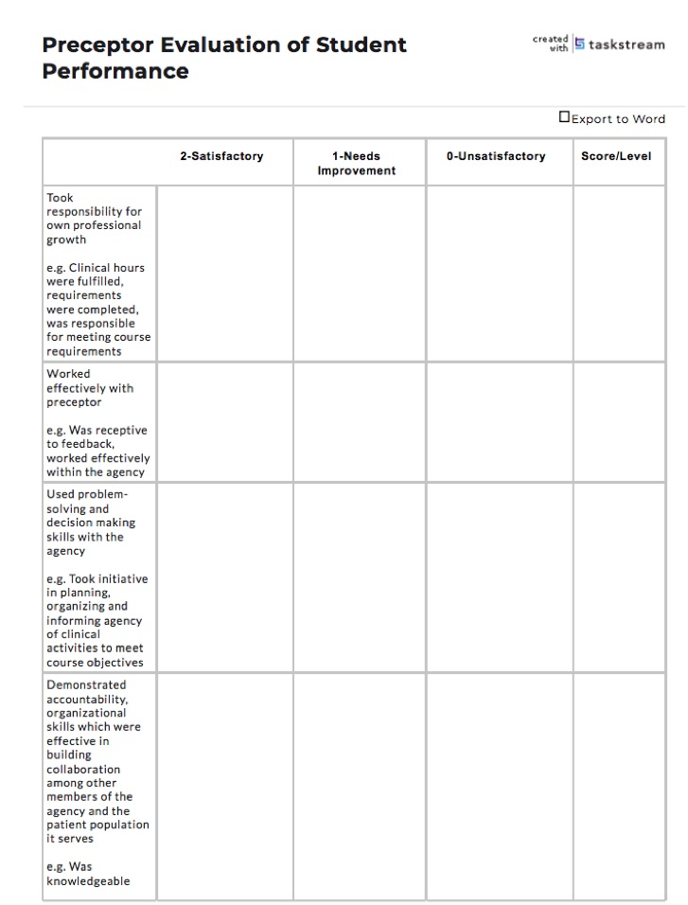
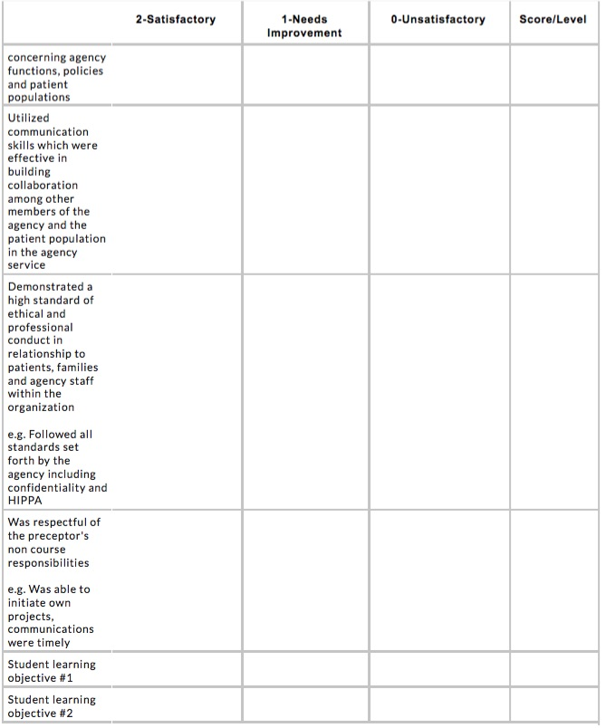

DEFIANCE COLLEGE ONLINE RN TO BSN COMPLETION PROGRAM
PRECEPTOR INTERACTION REGARDING FACULTY: NRS 476 & NRS 498

In an effort to improve the Defiance College ONLINE RN to BSN Completion Program for our students, clinical agencies and preceptors we welcome any feedback that you feel is valuable in assisting us with this mission:

Student Name:

COURSE NUMBER:
_______ NRS 476 Community Nursing Clinical
_______ NRS 498 Leadership Capstone

Did you receive information from the RN to BSN Program in a timely manner prior to the start of the Semester?
YES: NO:

Optional Comment:

Did the Course Instructor provide their contact information to you?
YES: NO:

Optional Comment:

Did the Course Instructor provide you with the information to adequately precept the student in the clinical component of this course?
YES: NO:
Optional Comment:

Did the Course Instructor email or call you at least once during your time with the student? Visit with you, if requested?
YES: NO:

Optional Comment:

Would you recommend being a preceptor to others?
YES: NO:

Optional Comment:

Is the contact with the course instructor enough to assist you in the role as a preceptor? (If no, please provide explanation in Optional Comment)
YES: NO:

Optional Comment:

Please feel free to share any other additional comments or suggestions below. If you would like to be contacted about your comments, please provide a contact number. Thank You.

Assessment Notes

Ongoing Assessment
Your assessment of the RN to BSN Completion Student is important on an ongoing basis throughout the semester. If at any time you would like to request a meeting with the clinical course faculty and/or Program Director, we encourage you to contact us.
When assessing adult learners it may be helpful to review adult learning styles (see addendum).
When to Assess
We recommend that you meet with the student at:
- The beginning of the clinical to review the student’s learning objectives and how
best the student can meet these objectives
- During the semester to monitor the student’s progress on an ongoing basis
- Final evaluation to determine the student’s performance in collaboration with the course faculty. The course faculty will be responsible for completing the Evaluation of Student Performance form and deciding on the student’s final points given for the clinical; however, the course faculty will want your opinion, so please review the evaluation form and be prepared to contribute your thoughts on student performance.

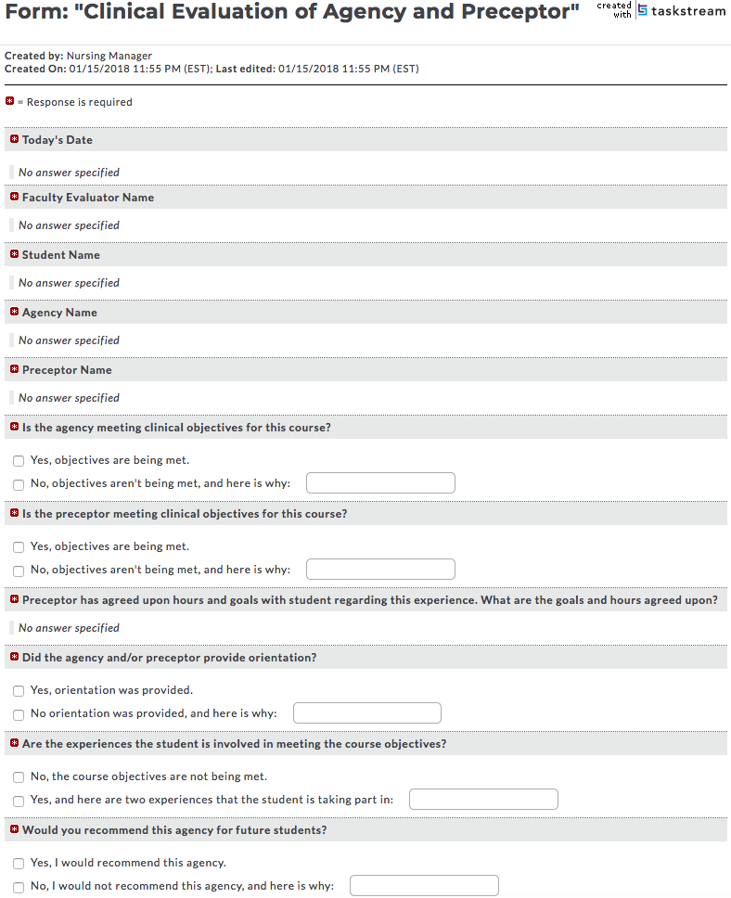
The following form is completed in Taskstream by Course Instructor only:
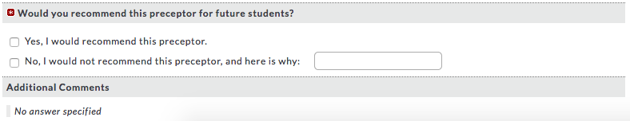

Student Forms and Instructions

Students are responsible for completing and/or maintaining the following tasks and forms:

Documentation of On-Site Clinical Experience
This form is to be maintained by the student on a weekly basis in Taskstream. The student should have all information listed on the form filled out in its entirety at the time of submission. This form needs to be submitted to the Preceptor (not to the Course Instructor) via email so that they can verify completion of on-site clinical time.

Documentation of Project Hours Clinical Experience
This form is to be maintained by the student on a weekly basis in Taskstream. The student should have all information listed on the form filled out in its entirety at the time of submission. This form needs to be submitted to the Preceptor (not to the Course Instructor) via email so that they can verify project hours for clinical time.

Student’s Assessment of Experience with Preceptor
This form is to be completed and submitted by the student in and through Taskstream to his/her Course Instructor at the end of the semester.

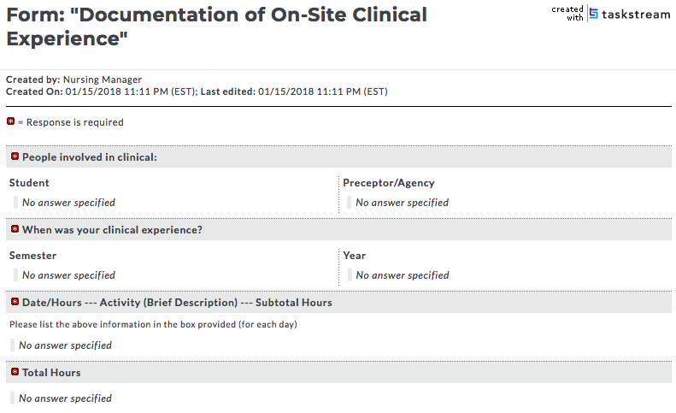
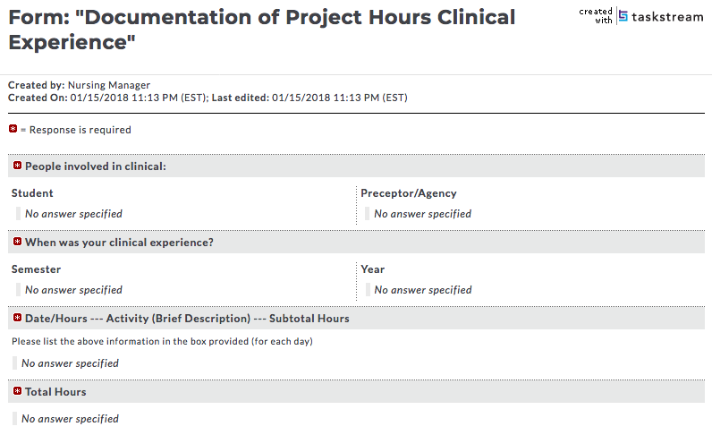
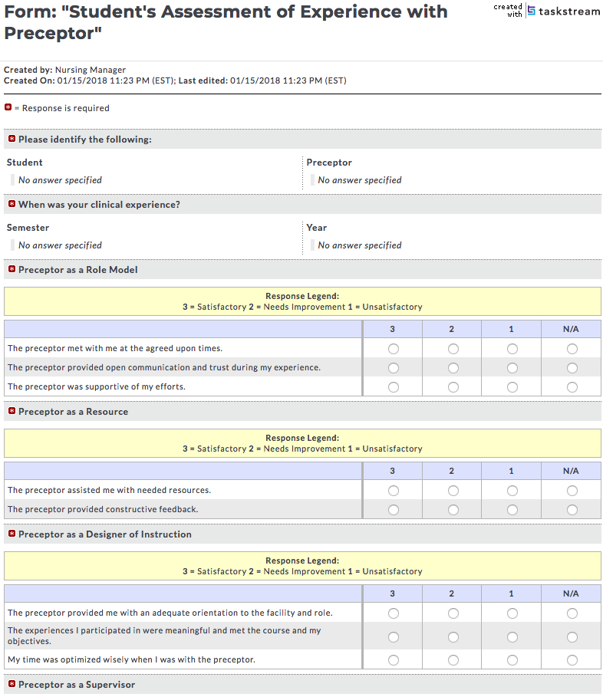

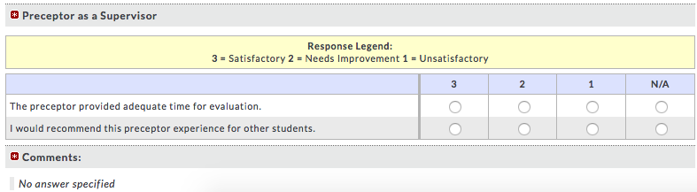

Addendum

ADULT LEARNING STYLES (Ulrich & Haffer, 2001)

In the 1970s, Malcolm Knowles introduced the concept of andragogy, identifying the general learning processes of adults. The concept is based on five basic principles.

- Adult learning is characterized as problem centered rather than subject centered and by the need for immediate rather than postponed application of knowledge.

- The learners are interested in solving the problems associated with their assignment (concrete variables directly relating to the individual) rather than integrating abstract subject matter that seems to have no direct bearing on the situation at hand.

- They are interested in learning things that will help them NOW.

- Timing of feedback is important.

- Learning is enhanced if learners are able to apply what they have learned within a short time.

- The longer the interval between performance and feedback, the less likely it is that feedback will have a positive effect on learning.

- Ideally, the preceptor should give feedback immediately after the skill has been performed.

- Feedback should be in terms of the stated learning objectives.

- Feedback should be descriptive rather than judgmental.

Strategies

- Concentrate on providing learning experiences most meaningful to the learner at the time.

- Use problem-centered approach to learning, relating usefulness of material to current or anticipated problem.

- Streamline learning activities presented to those required or relevant to the adult learner in his or her role.

- Schedule applied learning experiences soon after the learner finishes training, so that he or she can apply recently acquired knowledge.

- Provide feedback regarding students' behavior rather than their personal characteristics.

- Provide accurate feedback based on seen or heard observations rather than assumptions or inferences.

- Use neutral description rather than judgment-laden rhetoric, in your feedback.

- Feedback should include the amount of information the learner can use, not the amount you would like to give.

- Feedback should be the basis for sharing ideas and information.

2) Adult learning is related to an adult's readiness to learn, which is associated with life stage and life tasks.

- A student's learning is enhanced if teaching strategies include acknowledgment of his or her life stage and life objectives, as well as goals.

- Students' readiness to learn is determined by their developmental state and resultant tasks to be accomplished.

- Differences in maturation, tasks they have already accomplished, and cognitive capacity influence both what is learned and the rate of learning.

- Learning needs often become secondary to the preceptee's responsibility to family, job, and community.

- Because adult learners see themselves as achievers, they want to be treated with respect. They avoid situations over which they have little control. They do not want to be told what they can and cannot do, be talked down to, or be pre-judged.

- Adult learners learn best in an environment that does not threaten their self-concept and self-esteem.

Strategies

- Attempt to integrate new concepts and ideas with your preceptee's established beliefs, values, and attitudes.

- Expose your student to information in sequencing chunks, rather than bombarding him or her with large amounts of information.

- Be sensitive to the fact that your student's concurrent responsibilities may affect learning readiness and the quality of his or her participation in learning activities.

- Avoid speaking to the adult learner in an authoritarian manner.

- Adults have accumulated past experiences that serve as resources for learning.

- Learners who have had past experiences with a certain system or with populations of health care consumers often seek additional experiences associated with that system or group.

- This gives them a wealth of experiences from which to draw and a framework on which to build.

Strategies

- Learners who have had past experiences with a certain system or with populations of health care consumers often seek additional experiences associated with that system or group.

- This gives them a wealth of experiences from which to draw and a framework on which to build.

- Try to determine the background knowledge, skills and experiences of your preceptee; recognize your student’s previous abilities and build on them.

- Relate current learning to your student’s past experiences, as appropriate, and project current learning into its future applications.

- Share your own work experiences that might enhance your student’s learning experience.

4) Adults become increasingly independent and self-directed as they age.

- Because of past experiences, adult learners’ problem solve and demonstrate critical thinking strategies before seeking assistance. The learning process is an active process.

- Sometimes students are resentful and resistant when they are not allowed to set their own direction and be actively involved in their own learning.

Strategies

- Involve your student in all phases of the learning process including a collaborative identification of learning needs and development of learning objectives.

- Respect differences in the student’s values, beliefs and interpretations.

5) Adult learners are more often motivated by internal needs than by external
pressures.

- The teaching role is not one of initiating and motivating the learning process, but rather one of removing or reducing obstacles to learning and enhancing the process after it has begun.

- You need to let the student learn at their own pace, reduce anything perceived as a threat in the learning environment, and help the student focus on learning instead of obligations.
Strategies

- Promote your preceptee's feelings of adequacy, competency, and security through positive reinforcement.

- Provide a safe, open, non-authoritarian atmosphere.

- Minimize environmental or social variables that restrict learning opportunities. Modify the physical environment to reduce distractions.

Facilitating Learning
Preceptors facilitate learning by using a variety of teaching methods that meet the various learning styles of preceptees by incorporating the following strategies.

Try to use as many of these as possible when teaching your preceptee:

1. Proceed from the simple to the complex.
- Begin with the simplest procedures.
- Build on the known to reach the unknown.
- Use terms and examples that are familiar to your preceptee.

2. Incorporate planned sequences of learning.
- Build on known skills and progress in a step-by-step sequence toward goal.
- Teach tasks in small chunks that are easy to cognitively process.
- Use the natural breaks or pauses in job sequence to help identify "chunks" or
stages for teaching. Each chunk becomes a unit or section of training.

3. Strive for immediate application of new knowledge, then build on
success.
- Use new knowledge immediately.
- Positive reinforcement promotes feelings of success and stimulates
student motivation for further learning.

4. Engage in one-to-one activities with your preceptee.
- Informally teach your preceptee, demonstrating skills and using dialogue.
- Simultaneously assess his or her level of understanding of the process.
- Use the one-to-one relationship for role modeling as your preceptee
observes your behavioral responses.

5. Use informal teaching sessions with conferencing and dialogue.
- Theoretical constructs and skills practice can be reviewed away from the
intense work setting.
- Allow for information processing in a safe environment.

6. Allow for practice.
- Perform the skill in its entirety, first at normal speed and then more slowly.
- Talk your way through the skill, and invite the preceptee to ask questions.
- Repeat the demonstration, letting the preceptee copy what you are doing.
- Finally, let the preceptee perform the task without any assistance.

7. Validate that learning has occurred
- Allow the preceptee to demonstrate the newly acquired skill.
- Ask simple questions to determine preceptees recall of pertinent information.
- Be sure the preceptee has mastered the skill and is prepared to build on the
simple in order to move to the complex.
A Word About Coaching

The role of the preceptor includes coaching as well as teaching. Using the five-step coaching process, you can effectively guide your preceptor toward achieving specified learning goals.

Step 1: Clarify the work activities
At the beginning of the shift, collaborate with the preceptee to plan a timeline
indicating how, when, and by whom each activity is to be done.

Step 2: Review progress and potential or real problems
Take 5 minutes at the end of each shift (and PRN) to analyze the progress towards goal attainment. The dialogue should be mutually determined. Offer positive and critical feedback using neutral communication.

Step 3: Set priorities
Collaborate with the preceptee to prioritize problems, working at meeting the challenges of the most important ones first.

Step 4: Set objectives for goal attainment
Mutually define a specific goal for the preceptee to work on and develop interventions for attaining the goal. Include time frames and deadline dates.

Step 5: Review and evaluate the results
Together, review the preceptees accomplishments.

All information in this handout was taken directly from:
Ulrich, S. & Haffer, A. (2001). Preceptor: A Nurse’s Guide to Mentoring (CD ROM).
Philadelphia, PA: F.A. Davis Company.

Directory

Director of Nursing
Dr. Heidi DeSota, DNP, RN
Phone: (419) 783-2372
Phone: (419) 576-7103
hdesota@defiance.edu or Nursing@defiance.edu

Administrative Assistant & Taskstream Coordinator
Cathy Behringer
Phone: (419) 783-2573
cbehringer@defiance.edu

Moodle
Location: Defiance Hall, Room 203A and Pilgrim Library, Room 123 (during testing)
Sharon Wiemken (Director of Academic Technology and Online Learning)
Phone: (419) 783-2490 from 8:00 am to 4:30 pm
24-hour Emergency Coverage: (419) 576-0884
swiemken@defiance.edu
moodle@defiance.edu(help desk for Moodle issue)

Library Staff Resource
Location: Pilgrim Library, library.defiance.edu
Email: library@defiance.edu [additional after-hours resource]
Chat: library.defiance.edu [FAQs also found here]
Phone: (419) 783-2481
M-Th: 8 am to Midnight, Fri: 8 am to 4:30 pm, Sat: 9 am to 5 pm, Sun: 3 pm to Midnight
*Hours of various services differ and all times are EST

Taskstream Help
Phone: 1-800-311-5656
Help Site: https://help.taskstream.com/
Email: help@taskstream.com

